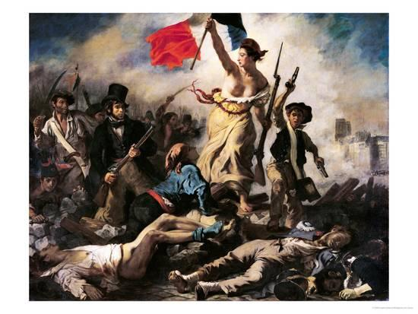
Liberty Leading the People by Eugène Delacroix

