For immigrant children, fate in U.S. a roll of the dice
By Mariano Castillo, CNN
Elvin Castañon, a ninth-grader with a quiet demeanor and razor-sharp memory, admits that luck played a pivotal role in his being in school. Or in the United States, for that matter.
He's lucky to have survived atop "The Beast" — the train that some migrants cling to across Mexico — with all his limbs intact. Lucky to have escaped notice at the border, straddling a fence as Border Patrol agents chased other people on the ground. Lucky to have been picked up by the Border Patrol when he was — after days sleeping in the brush and surviving on scraps. "I stop and think and the first thing I think is about God," he said, reflecting on all the things that have put a green card within his reach. "I think he wanted something good for me, to give me the opportunity to do good."
Elvin left his Guatemalan village near the Mexican border in November 2012, three days after a 7.4-magnitude earthquake destroyed his family's home. He claims he wasn't fleeing persecution — a requirement for asylum in the United States — and if he had sought that route he likely might have been deported. But there are U.S. laws that are meant to protect unaccompanied minors, and one such alternative has paved the way for him to likely stay here. What he considers luck, some in his new host country see as problematic — evidence of an unsecured border or lax federal immigration policies that have hastened the flow of Central American migrants. There is wide agreement among Americans that once unaccompanied migrant children are in federal custody, their fate should not be a matter of chance.
As a practical matter, though, the question of whether children like Elvin get to stay in the United States largely hinges on two factors that often are beyond their control — whether they have a lawyer and which of several dozen immigration judges nationwide happen to hear their case. Whether young immigrants get a lawyer is often a matter of luck. And immigration judges often make wildly different decisions after weighing similar facts. Some judges interpret the law in a way that lets immigrants stay in the United States more often than not. Others hear similar arguments and tend to expel the immigrants who make them.
As for the public, nearly 70% of Americans believe that migrant children from Central America should be treated as refugees and allowed to stay in the United States if it is deemed unsafe for them to return to their home countries, according to a July poll by the nonpartisan Public Religion Research Institute.
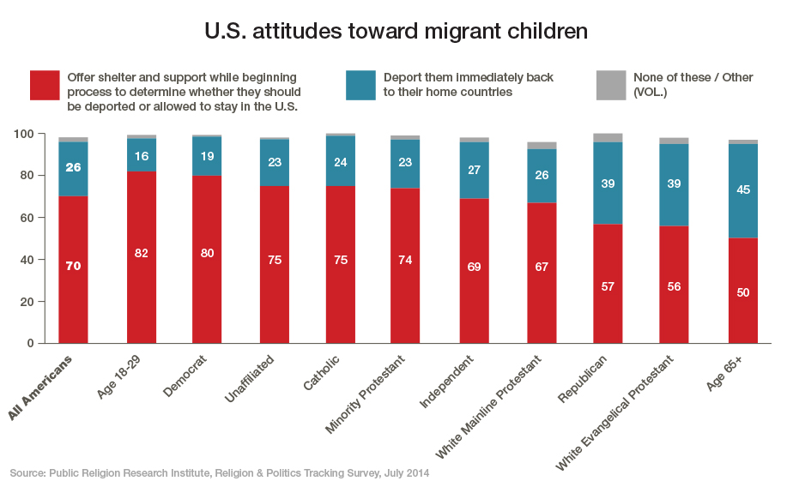
For children, representation makes a difference
Unaccompanied minors in the U.S. immigration courts system face a mountain of procedures, forms and customs that they don't understand, advocates say. For many, the language is foreign, too.
"It's hard for me to fathom that a child could articulate in court what they need — they don't know what to ask and when to ask it," said Ashley Huebner, managing attorney for the National Immigrant Justice Center's Immigrant Children's Protection Project in Chicago, which defends minors detained in the area.
Since 2005, nearly 50% of the children who had lawyers when they faced an immigration judge were allowed to stay in the United States. In contrast, only 10% of children who went to court without an attorney were permitted to stay.
That comes from the nonpartisan Transactional Records Access Clearinghouse at Syracuse University. TRAC released a report in July based on information culled from open records requests made to the Executive Office for Immigration Review, which runs immigration courts as part of the Justice Department.
The odds are generally stacked against migrant children, Huebner explained. If a child is detained in an area that doesn't have a sophisticated system of pro bono immigration attorneys, advocates, and charity groups experienced at working with migrants, it's likely the child will fall through the cracks and not get an attorney.
Of the approximately 28,500 juvenile cases in immigration courts nationwide as of June, only 31% of defendants had attorneys, according to TRAC data.
One Washington-based nonprofit organization that dedicates itself to providing legal representation for unaccompanied minors, Kids in Need of Defense, estimates that with this year's mass influx of Central American children, between 70% and 90% could go unrepresented.
What these numbers mean, experts say, is that immigrants who should qualify under the law for asylum or other relief — but lack an attorney — may be deported. There are cases where children are deported back to dangerous or life-threatening situations.
"We talk about access to protection, but this can be meaningless if they don't have an attorney," said Megan McKenna, communications and advocacy director at Kids in Need of Defense.
Getting placed in the system
Elvin, the boy from Guatemala, said he risked migrating illegally to the United States to work and send money to his parents after the quake devastated their home. "It was my idea, to help my family," he said. For 16 days, he traveled north from Guatemala, mostly on "The Beast," also known as the "Train of Death," and then by bus until he reached the Mexican border city of Reynosa. After 10 days at the border, Elvin attempted to cross the border along with about 45 others and a smuggler. Just as it was his turn to climb over the border fence at Hidalgo, Texas, the Border Patrol swooped in and the migrants on the ground fled. The officers chased them. No one looked up and noticed Elvin, by himself, straddling the fence. "I stayed there for a moment, just thinking," he said. "I felt a little strange. Here I was all by myself." He slowly lowered himself onto Texas soil and began walking.
Elvin said he languished for days outside, in a futile wait for other migrants who might pass by and help him get his bearings. After four days, he gave up and started walking down one of Hidalgo’s main streets, hoping to get picked up by authorities. One Border Patrol vehicle drove past, then another, and then another. But no one paid attention to Elvin. It was the fourth Border Patrol truck that stopped, and Elvin readily admitted he had crossed illegally.
The teen was taken to the "hielara" — the ice box, the name migrants give to the Customs and Border Protection holding cells because of their chilly temperatures. After officers asked him his age and where he was from, he was promptly transferred to a facility run by BCFS, a human services nonprofit agency. BCFS is contracted by the Office of Refugee Resettlement, which falls under the U.S. Department of Health and Human Services, to run the shelter. The agency, formerly known as Baptist Child and Family Services, provides the transition from government custody to resettlement for most unaccompanied migrants who enter the country illegally. Currently, an unaccompanied minor spends less than 30 days on average in government care, HHS spokesman Kenneth Wolfe said.
From government care to the courtroom
The fact that the children are unprepared to face a foreign legal system is not lost on the government officials, who invite advocates to educate the minors on what to expect. All unaccompanied children in the ORR's custody attend a mandated "know your rights" workshop, Wolfe said. Children as young as 6 participate in these workshops, where they are handed a booklet of about 25 pages that explains the justice system. The advocates who provide these classes understand the challenge of getting young people to grasp the material.
In Illinois, advocates from the National Center for Immigrant Justice say they begin by showing the children maps and asking, "Where are you now?" Then they ask the children to point out where they are from. And the teachers make use of analogies — for example, comparing the Immigration Court process to the World Cup. "We say there are two sides — the lawyers—and one ref — the judge," said Molly Castillo-Keefe, who has supervised the classes. The children are told that they must show up when they get a court date. "What happens when you don't show up to court?" the teacher asks.
The children shout back: "You lose the game!"
After class, an advocate sits next to each child and teaches him or her how to dial an 800 number and how to punch in the right numbers, so that when the children are released from ORR custody to relatives in the United States, they will have some chance of being able to keep up with where their cases stand in the usually plodding Immigration Court system.
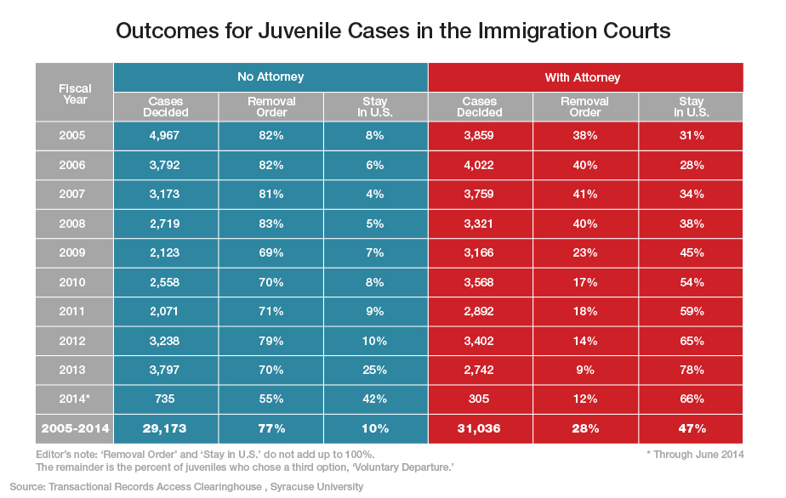
Released into a new reality
Elvin's next journey — from detention on the Texas border to an apartment near Atlanta — highlights how easy it is for a juvenile migrant to fall through the cracks. Just two days into his stay in ORR custody in Texas, Elvin was assigned a social worker, he said. At the facility there, he was provided food and schooling and attended a "know your rights" class. He paid attention, but some of the material was too complicated for him and the other children, he said. "Some were interested (in learning about the process), but others weren't interested at all," he said. Attorneys from the group that made the presentation represented Elvin in Texas.
This is what Elvin recalls about his first appearance before a judge: A large group of undocumented immigrant children were there with him. The judge asked each one if they wished to be voluntarily deported or if they wanted more time to prepare their cases to fight their pending deportation orders. Everyone asked for more time, Elvin said. The judge was patient, he said, giving everyone more time. "I didn't have any idea (about the process), but the lawyer working my case knew how to determine if I qualified to stay," Elvin said.
Usually, after attending a "know your rights" class and having a court date assigned, children are released from ORR custody and turned over to relatives living in the United States, explained Rebeca Salmon, an Atlanta-based immigration attorney. Elvin said he stayed under ORR care for much longer than what officials say is the average time in custody. After about three months, he was told he risked deportation if he didn't find a place to stay. If a child doesn't have family in the United States, he or she can go to a variety of places. Sometimes they are placed in state care, Salmon said.
Elvin did have a relative in the United States — a cousin in Atlanta.
His lawyers in Texas transferred his pending immigration case to Atlanta and told him to show up at a court date there.
It was a by-the-book transfer from government care into society, but one that ultimately did not serve Elvin's best interests. In Texas, Elvin was taking classes and getting homework help from the staff at the ORR facility there.
Once he arrived in Atlanta, his cousin claimed he couldn't get Elvin enrolled in school. Still 16 and not attending school, Elvin decided to look for work despite not having a work permit. He tried to take any job he could, but it was obvious to contractors that he was too young, he said. But the demand for cheap labor eventually won out, and Elvin was eventually hired as a roofer. This was his new life in America; his upcoming court hearing was not on his mind.
Judge roulette
As Elvin's story illustrates, it can take months before the meat of the case — a child's defense against a deportation proceeding — comes before a judge. And it matters which judge.
The most common and well-known avenue available to immigrants is to ask for asylum. Children may qualify for other special designations that bestow legal citizenship, depending on their circumstances. One refrain heard from immigration lawyers is what they see as a lack of consistency in Immigration Court. Some judges are known to interpret the law strictly, others more leniently. And the differences aren't small.
TRAC, the Syracuse program that tracks juvenile immigrant cases, maintains a database of the records of immigration judges, as reported by the government. The more than 260 immigration judges use their individual discretion in their rulings, though all operate under the same legal framework. The TRAC data show disparities that are bigger than one might expect. When it comes to asylum bids (from adults or children), some judges reject these petitions only four out of 10 times. Others reject nine out of 10 asylum applications.
There are some obvious factors that play a role — the number of cases they hear, the countries of origin of the asylum applicants — but some say personal bias and political views color the rulings more than they should. "Basically, it's luck. It's like going to a casino," Atlanta-based immigration attorney Glenn Fogle said. "Maybe you get a judge who feels sorry and believes you have a good claim — or next door you might get the guy who denies everybody," he said. Fogle said he can't pinpoint the exact reason for the disparity in how immigration judges rule, but thinks that personality, political views and agendas all come into play. Some judges are predisposed to disbelieve applicants or discredit their stories, Fogle said.
Mark Metcalf, a former immigration judge in Miami, sees another reason some judges are stricter than others: experience. He said a court with many asylum rejections may be a sign that the judge and prosecutor have heard certain types of arguments before and know better how to detect fraudulent stories. Metcalf rejected about 90% of asylum claims between 2007 and 2012. He said it's not unreasonable for a judge to scrutinize the stories of undocumented immigrants in court, given the current politics of immigration.
Despite criticism aimed at the Obama administration by immigrant advocates for its record number of deportations, Metcalf said the reality is that very few people actually leave the country. Deportation orders are seldom enforced, he said. Experts say that the enforcement of deportation orders varies from state to state. It is the duty of Immigration and Customs Enforcement to carry out the deportations, but the agency must balance that with other security and investigative priorities.
Once in the system, an undocumented immigrant can decide not to appear in court, or simply forget. When a deportation order is issued in absentia, he or she is nowhere to be found. Current immigration policies are part of a system that favors immigrants, Metcalf said.
Word gets back to others in Central America that once you get your foot in the court system, there is a good chance of staying in the United States, he said. Immigrants who have been granted asylum coach others from their home countries on what to say to increase their odds, Metcalf said.
Immigration judges don't operate in a vacuum, the former judge said — "They know what's going on out there." Some judges read cases more leniently than he did during his tenure, Metcalf conceded. The human element, a bias for people's plight and compassion rule for many, he said. Are some judges too strict? They are hopefully balanced out by those who read the law too liberally, he said. His hope is "to get a standard of justice that gets it right more often than wrong and is acceptable" to the public and Congress, he said. He sees a system that is fair, but overburdened.
"The system has very good judges on the whole," he said.
Luck, and a new attorney
Nearly a year had passed since Elvin left his home in Guatemala, and things were getting even more complicated in Georgia. His cousin, who had taken him in, had his own family to take care of and told Elvin he could no longer care for him. A helping hand from one of his supervisors at his roofing jobs would change Elvin's life trajectory once again. The supervisor, also Guatemalan and living in the country illegally, offered Elvin a place to stay. "I knew he was a hard worker," the man said. "He reminded me of myself at that age, working hard to make it work." He took Elvin into his home and got him back in school. And he encouraged the teen to follow up on his Immigration Court date. But Elvin missed his court date. The consequences could be severe, and Elvin began asking around for recommendations for an attorney.
He found Rebeca Salmon. In an almost unbelievable stroke of luck, she found, the day that Elvin missed his court hearing was also a day that the immigration judge had been out. Because the judge wasn't in, Elvin's court date was rescheduled and he avoided any penalties. Salmon had other ideas for Elvin's case, too.
A fair outcome?
Sitting in his bedroom, Elvin is straightforward about his decision to sneak into the United States. There was an earthquake that disrupted his life, and he wanted better economic opportunities. Elvin said he did not face threats from gangs, was not the victim of government repression, and did not fear for his life or safety back home.
Most people are familiar with asylum as a path to be granted the right to stay in the United States. But asylum has very specific requirements that must be met — including having a "credible fear of persecution." Would a judge in Atlanta, where statistics show judges are stricter than average, have granted Elvin asylum? Some would say he lacks a strong enough case to remain in the United States, given his own admission that he entered the country illegally not out of fear of persecution, but for economic opportunity. But Salmon, his attorney, questions how a child in a foreign land can fully understand the situation that brought him here.
Elvin says he chose to come to the United States. "Children don't make decisions," Salmon counters. "They don't choose to come; he decided to flee." In her view, an immigrant child might say that life is "normal" back home, but that word means different things depending on where you stand. "Normal" in Guatemala for Elvin meant no schooling after the earthquake, poor nutrition and the presence of deadly gangs, whether or not they had threatened him yet, she said. A judge would have to make the final determination — how to balance what a child says against the facts about his or her home country.
In Elvin's case, Salmon instead navigated him through another option for unaccompanied minors, rather than petitioning for asylum. Now 17, Elvin was basically on his own, staying with his former work supervisor after his cousin left town. Abandoned, in a sense. Elvin's future in the United States could hinge on that word — "abandoned." With no one to look after him, his host — his former supervisor — went one step further and petitioned for legal guardianship of Elvin. It was a state Juvenile Court judge, not an immigration judge, who granted custody of Elvin to his host. But it was a key decision.
It made Elvin eligible for what is known as Special Immigrant Juveniles Status. The law states that if an undocumented minor is placed in custody of a guardian by a Juvenile Court, and it is not in the child's best interest to return to his home country, and reunification with his parents is not viable, then legal status in the United States can be granted. Elvin said he misses his parents, but he added that he does not want to be reunited with them for now. His original plan was to send money back to them, something he admits that, because of school, he cannot do.
His lawyer declined to go into specifics of what she argued in regard to why reunification was out of the question, but said the judge found it sufficient to agree that it is not in Elvin's best interest to return to Guatemala. According to Salmon, Elvin's petition for Special Immigrant Juveniles Status has been accepted, and all that remains before being granted residency is for an immigration judge to cancel the deportation order against him.
His is a complicated case, but not unlike tens of thousands of others. Elvin admits that he would not have had a clue about how to manage the system without an attorney. He doesn't know the name of the immigration judge who handled his case, nor does he understand the arguments that his attorney has made on his behalf, he said. The likely outcome of his case will look like justice to some and a gaming of the system to others. It is a legal journey that is playing out currently for thousands, many of them without attorneys.
For Elvin, the goal is to attain what he could not get back home.
"I have faith I will be allowed to stay here," he said, "and keep working."
CNN's Ashley Fantz contributed to this story.

